You will find the site specific information by clicking on each colored icon on the map.
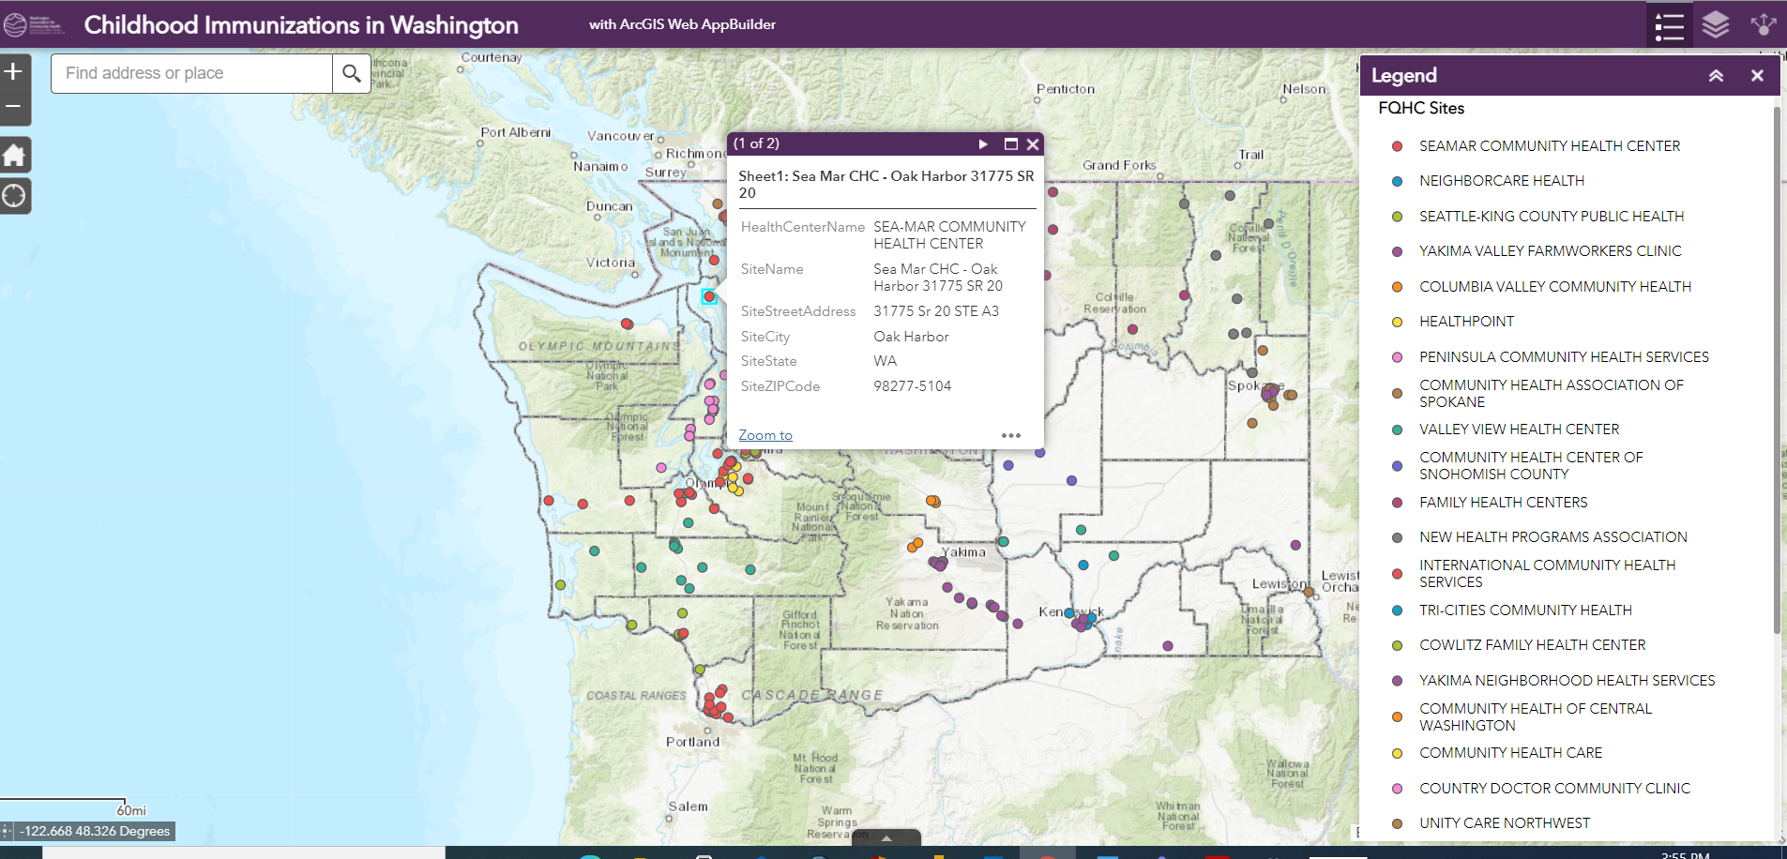
The layers can be found by clicking the middle icon on the right hand side of your screen. Layers can be selected by clicking on the check box next to the layer name and the measures for each layer are described by clicking on the arrow next to the layer name.

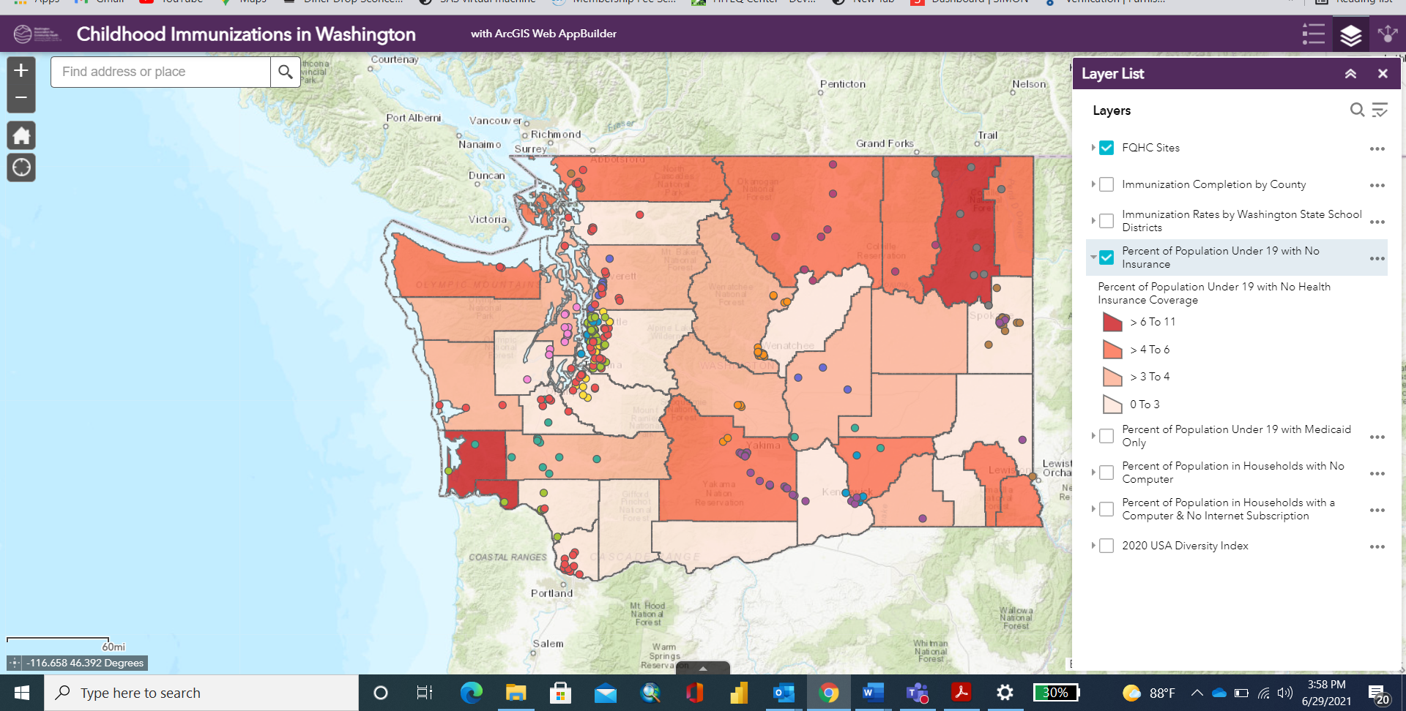
This map is designed for planning around Childhood Immunizations goals and strategies. If you have questions about how to use this map, please contact knicholas@wacommunityhealth.org or hstandfield@wacommunityhealth.org.

